**Lab : Streaming to Snowflake with Python**

**Goal:** Build a Python streaming application that consumes data from a Redpanda Cloud topic and ingests it into a table in Snowflake in near real-time using key-pair authentication.

Purpose of the Lab

This lab is designed for developers and covers the critical use case of streaming data into a cloud data warehouse programmatically. You will write a Python script that acts as a long-running service, using standard client libraries to connect securely to both Redpanda and Snowflake. This lab provides practical experience in handling secure, key-pair authentication for Snowflake and building custom streaming applications that are central to modern data pipelines.

# **Prerequisites**

* A Redpanda Cloud account with a running cluster and an rpk profile (e.g., rpk-cloud).
* A Snowflake account with ACCOUNTADMIN privileges to set up the necessary objects.
* Python 3 installed on your local machine.
* OpenSSL installed on your local machine to generate a key pair.

# **Project Layout**

|  |
| --- |
| rp-snowflake-python-lab/ ├── sales_events.jsonl ├── snowflake_sink.py ├── manual_producer.py ├── .env └── snowflake_key.p8 |

# **Part 1: Setting up the Project and Snowflake**

## Step 1: Prepare the Project Directory and Generate Keys

First, we'll create our project directory and generate the necessary authentication keys directly inside it.

1. **Create and enter the project directory:**

|  |
| --- |
| mkdir rp-snowflake-python-lab cd rp-snowflake-python-lab |

1. **Generate a private key:**

|  |
| --- |
| openssl genrsa -out snowflake_key.p8 2048 |

1. **Generate the public key from the private key:**

|  |
| --- |
| openssl rsa -in snowflake_key.p8 -pubout -out snowflake_key.pub |

## Step 2: Create Snowflake Objects

Log in to your Snowflake account and open a new worksheet. Run the following SQL commands one by one.

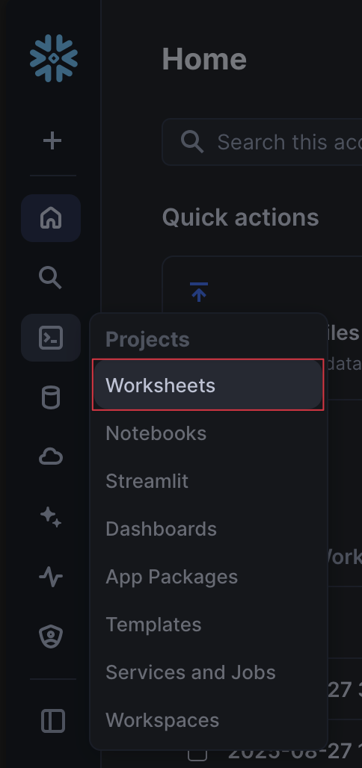

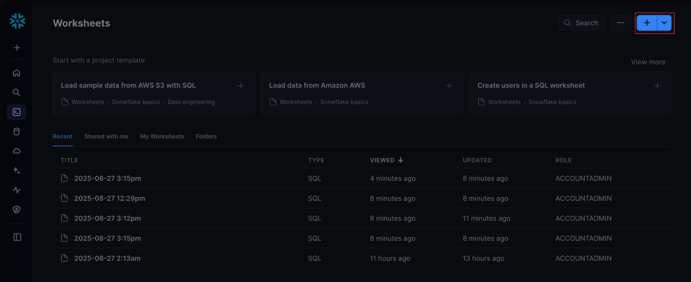

1. **Set up roles and warehouses:**

|  |
| --- |
| USE ROLE ACCOUNTADMIN; CREATE WAREHOUSE IF NOT EXISTS REDPANDA_WH; CREATE DATABASE IF NOT EXISTS REDPANDA_DB; CREATE SCHEMA IF NOT EXISTS REDPANDA_SCHEMA; CREATE ROLE IF NOT EXISTS REDPANDA_ROLE; GRANT USAGE ON WAREHOUSE REDPANDA_WH TO ROLE REDPANDA_ROLE; GRANT USAGE ON DATABASE REDPANDA_DB TO ROLE REDPANDA_ROLE; GRANT USAGE ON SCHEMA REDPANDA_DB.REDPANDA_SCHEMA TO ROLE REDPANDA_ROLE; GRANT CREATE TABLE ON SCHEMA REDPANDA_DB.REDPANDA_SCHEMA TO ROLE REDPANDA_ROLE; |

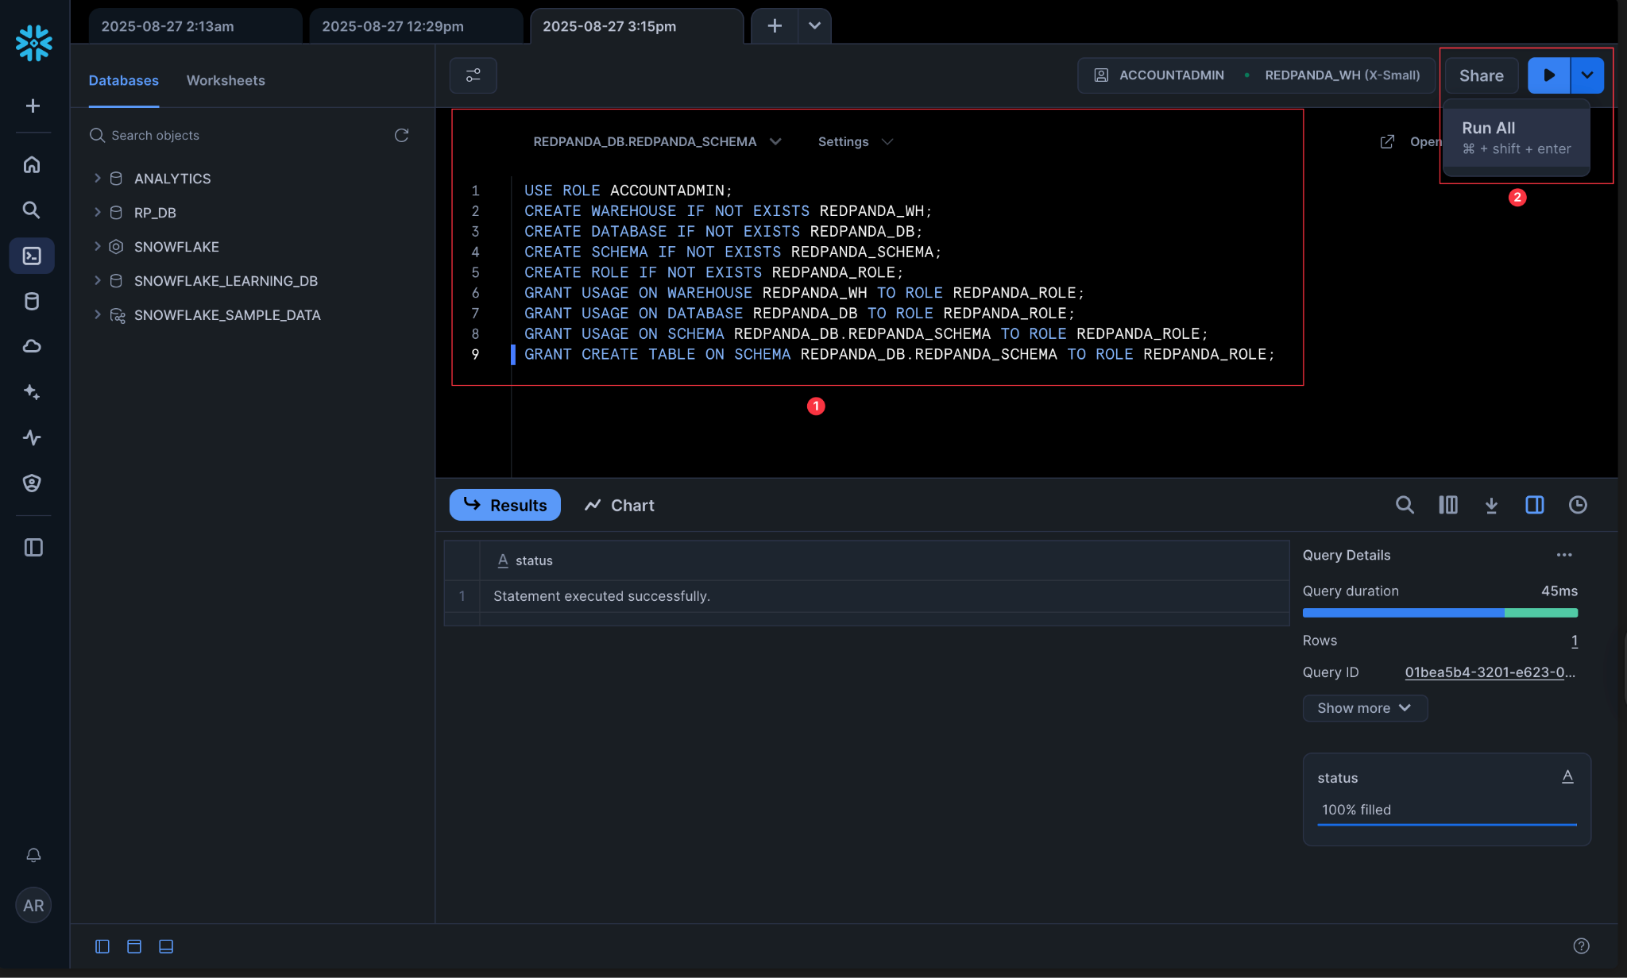

1. **Create a user and assign the public key:**  
   First, go to your terminal and run the command below to display your clean public key. Copy the entire single-line output.

|  |
| --- |
| cat snowflake_key.pub | grep -v -- '-----' | tr -d '\n' |

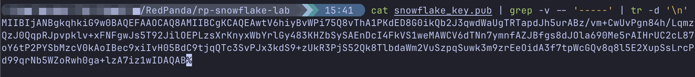

*(Note: Sometimes your shell may add a % character at the very end of the output string. This is not part of the key and should be removed before pasting.)*  
Now, paste the single-line public key string you copied into the RSA_PUBLIC_KEY field in the SQL command below and run it in your Snowflake worksheet.

|  |
| --- |
| CREATE USER IF NOT EXISTS REDPANDA_USER  PASSWORD = NULL  LOGIN_NAME = 'REDPANDA_USER'  DISPLAY_NAME = 'REDPANDA_USER'  RSA_PUBLIC_KEY = '<YOUR_PUBLIC_KEY_STRING>';  GRANT ROLE REDPANDA_ROLE TO USER REDPANDA_USER; ALTER USER REDPANDA_USER SET DEFAULT_ROLE = REDPANDA_ROLE; ALTER USER REDPANDA_USER SET DEFAULT_WAREHOUSE = REDPANDA_WH; ALTER USER REDPANDA_USER SET DEFAULT_NAMESPACE = REDPANDA_DB.REDPANDA_SCHEMA; |

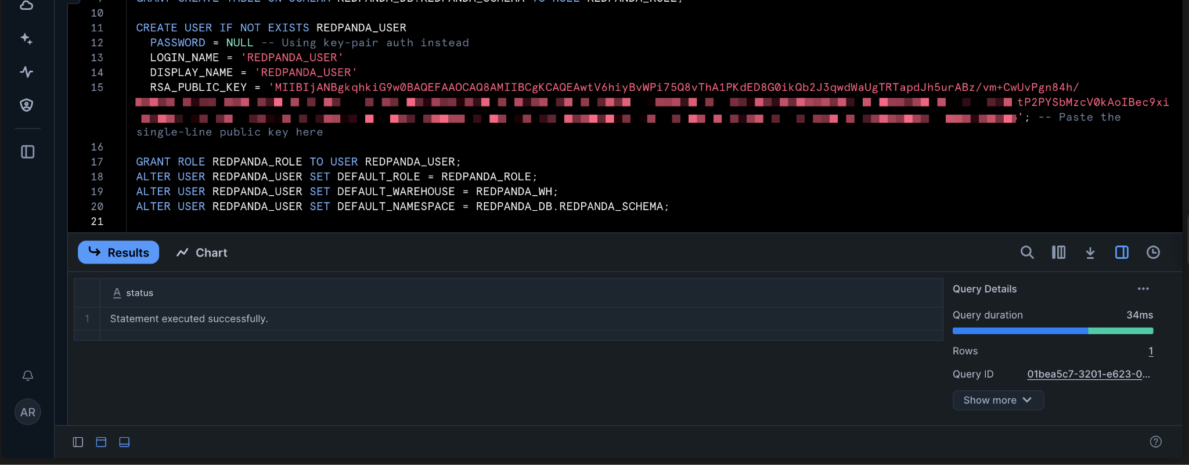

1. **Grant the new role to your own user:** Replace <YOUR_CURRENT_USERNAME> with the username you used to log in to the Snowflake UI.

|  |
| --- |
| GRANT ROLE REDPANDA_ROLE TO USER <YOUR_CURRENT_USERNAME>; |

1. **Create the target table:**

|  |
| --- |
| USE ROLE REDPANDA_ROLE; USE WAREHOUSE REDPANDA_WH; USE SCHEMA REDPANDA_DB.REDPANDA_SCHEMA;  CREATE OR REPLACE TABLE SALES_EVENTS (  EVENT_ID VARCHAR,  SALE_AMOUNT NUMBER(10, 2),  ITEM_SKU VARCHAR,  CUSTOMER_ID VARCHAR,  EVENT_TIMESTAMP TIMESTAMP_TZ ); GRANT INSERT, SELECT ON TABLE SALES_EVENTS TO ROLE REDPANDA_ROLE; |

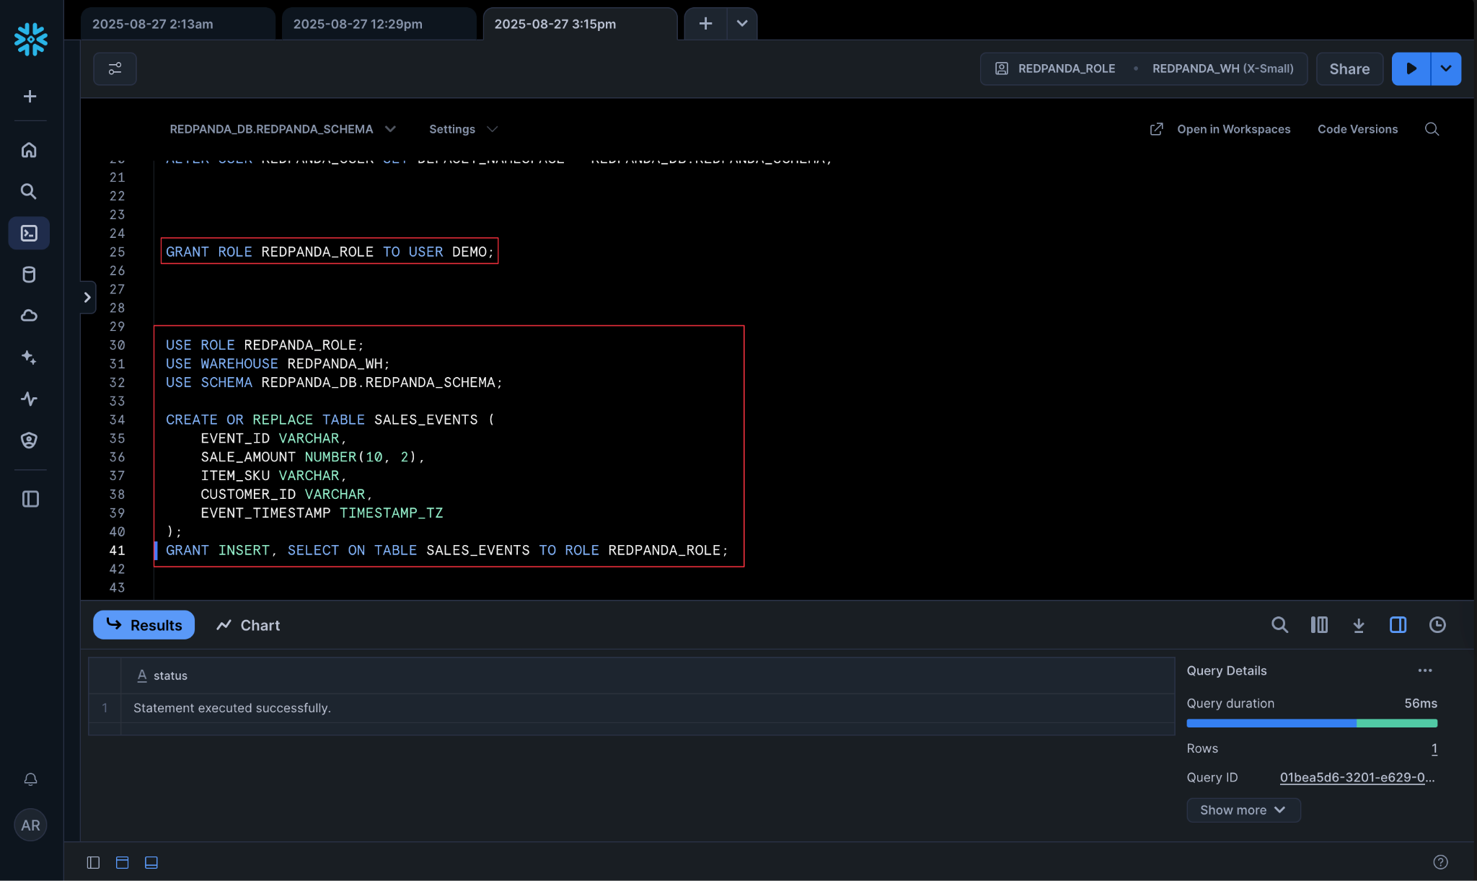

## 

# **Part 2: Setting up Redpanda and Python**

## Step 3: Get Redpanda Cloud Credentials

Create a new user (e.g., snowflake-py-user) in the **Security -> Users** tab of the Redpanda Cloud UI and grant it **Allow All** permissions in the **ACLs** tab. Save the **Username**, **Password**, and your cluster's **Broker Address**.

## **Step 4: Prepare Redpanda and the Python Environment**

1. **Create a sample data file named sales_events.jsonl :**

**sales_events.jsonl**

|  |
| --- |
| {"event_id": "a1", "amount": 19.99, "sku": "ABC-123", "customer": {"id": "cust-101"}, "timestamp": "2025-08-27T14:30:00Z"} {"event_id": "a2", "amount": 250.00, "sku": "XYZ-789", "customer": {"id": "cust-202"}, "timestamp": "2025-08-27T14:31:00Z"} |

1. **Create the topic on Redpanda Cloud:**

|  |
| --- |
| rpk topic create sales-events-py --profile rpk-cloud |

1. **Set up the Python virtual environment:**

|  |
| --- |
| python3 -m venv venv source venV/bin/activate  pip install kafka-python python-dotenv certifi python-snappy snowflake-connector-python cryptography |

1. **Gather your credentials for the .env file:**

* Redpanda Credentials: You will use the Broker URL, Username, and Password for the snowflake-user you created in Step 3.
* Snowflake Account Identifier: You can find this in the URL you use to log in to the Snowflake UI (e.g., abc12345.us-east-1 from https://abc12345.us-east-1.snowflakecomputing.com).

1. **Create the Environment File (.env):**

|  |
| --- |
| # .env REDPANDA_BROKERS="<YOUR_BROKERS_URL>" REDPANDA_USER="<YOUR_REDPANDA_USERNAME>" REDPANDA_PASS="<YOUR_REDPANDA_PASSWORD>"  # Snowflake Credentials SNOWFLAKE_ACCOUNT="<YOUR_ACCOUNT_IDENTIFIER>" SNOWFLAKE_USER="REDPANDA_USER" SNOWFLAKE_PRIVATE_KEY_PATH="snowflake_key.p8" SNOWFLAKE_DATABASE="REDPANDA_DB" SNOWFLAKE_SCHEMA="REDPANDA_SCHEMA" |

Populate the file with your credentials.

1. **Produce the data to the sales-events-py topic:**

|  |
| --- |
| rpk topic produce sales-events-py --profile rpk-cloud < sales_events.jsonl |

# **Part 3: Building and Running the Python Pipeline**

## **Step 5: Create the Snowflake Sink Script**

Create a file named snowflake_sink.py. This script will connect to both services and stream data.

**snowflake_sink.py**

|  |
| --- |
| # snowflake_sink.py import json, os, certifi from kafka import KafkaConsumer from dotenv import load_dotenv import snowflake.connector from cryptography.hazmat.primitives import serialization  # Load environment variables from .env file load_dotenv()  # --- Configuration --- BROKER_URL = os.getenv("REDPANDA_BROKERS") USERNAME = os.getenv("REDPANDA_USER") PASSWORD = os.getenv("REDPANDA_PASS") SOURCE_TOPIC = "sales-events-py"  SNOWFLAKE_ACCOUNT = os.getenv("SNOWFLAKE_ACCOUNT") SNOWFLAKE_USER = os.getenv("SNOWFLAKE_USER") SNOWFLAKE_PRIVATE_KEY_PATH = os.getenv("SNOWFLAKE_PRIVATE_KEY_PATH") SNOWFLAKE_DATABASE = os.getenv("SNOWFLAKE_DATABASE") SNOWFLAKE_SCHEMA = os.getenv("SNOWFLAKE_SCHEMA") # --- End Configuration ---  # Load and deserialize the private key with open(SNOWFLAKE_PRIVATE_KEY_PATH, "rb") as key:  p_key = serialization.load_pem_private_key(  key.read(),  password=None, # No password on the key file  ) pkb = p_key.private_bytes(  encoding=serialization.Encoding.DER,  format=serialization.PrivateFormat.PKCS8,  encryption_algorithm=serialization.NoEncryption() )  print("Starting Python Snowflake sink...") print("Press Ctrl+C to stop.")  try:  # Connect to Snowflake  snowflake_conn = snowflake.connector.connect(  user=SNOWFLAKE_USER,  account=SNOWFLAKE_ACCOUNT,  private_key=pkb,  database=SNOWFLAKE_DATABASE,  schema=SNOWFLAKE_SCHEMA  )  print("Successfully connected to Snowflake.")    # Connect to Redpanda  consumer = KafkaConsumer(  SOURCE_TOPIC,  bootstrap_servers=BROKER_URL, security_protocol="SASL_SSL",  sasl_mechanism="SCRAM-SHA-256", sasl_plain_username=USERNAME, sasl_plain_password=PASSWORD,  group_id="snowflake-python-sink-group", auto_offset_reset="earliest",  ssl_cafile=certifi.where(), api_version=(2, 0, 2),  value_deserializer=lambda v: json.loads(v.decode('utf-8'))  )   for message in consumer:  event = message.value  print(f"Received event: {event}")    # Insert data into Snowflake  snowflake_conn.cursor().execute(  "INSERT INTO SALES_EVENTS (EVENT_ID, SALE_AMOUNT, ITEM_SKU, CUSTOMER_ID, EVENT_TIMESTAMP) VALUES (%s, %s, %s, %s, %s)",  (event['event_id'], event['amount'], event['sku'], event['customer']['id'], event['timestamp'])  )  print(f"Successfully inserted event {event['event_id']} into Snowflake.")  except KeyboardInterrupt:  print("Handler stopped by user.") except Exception as e:  print(f"An unexpected error occurred: {e}") finally:  if 'consumer' in locals(): consumer.close()  if 'snowflake_conn' in locals(): snowflake_conn.close()  print("Connections closed.") |

## Step 6: Run the Streaming Pipeline

Execute the script. It will process the existing messages and wait for more.

|  |
| --- |
| python snowflake_sink.py |

**Expected output:** The script will connect to both services, process the two existing messages, and then wait for more.

## **Step 7: Test the Real-time Stream**

1. **Open a new terminal window** and navigate to the same project directory. Activate the virtual environment (source venv/bin/activate).
2. Create a small, separate producer script named manual_producer.py to send a single message.  
   **manual_producer.py**

|  |
| --- |
| # manual_producer.py import json, os, certifi from kafka import KafkaProducer from dotenv import load_dotenv  # Load environment variables from .env file load_dotenv()  # --- Configuration --- BROKER_URL = os.getenv("REDPANDA_BROKERS") USERNAME = os.getenv("REDPANDA_USER") PASSWORD = os.getenv("REDPANDA_PASS") TOPIC_NAME = "sales-events-py" # --- End Configuration ---  producer = KafkaProducer(  bootstrap_servers=BROKER_URL, security_protocol="SASL_SSL",  sasl_mechanism="SCRAM-SHA-256", sasl_plain_username=USERNAME, sasl_plain_password=PASSWORD,  value_serializer=lambda v: json.dumps(v).encode('utf-8'),  ssl_cafile=certifi.where(), api_version=(2, 0, 2) )  new_event = {"event_id": "a3", "amount": 99.50, "sku": "DEF-456", "customer": {"id": "cust-303"}, "timestamp": "2025-08-27T14:32:00Z"} print(f"Sending manual event: {new_event}") producer.send(TOPIC_NAME, value=new_event) producer.flush() producer.close() print("Done.") |

1. Run this manual producer script.

|  |
| --- |
| python manual_producer.py |

## Step 8: Verify the Results

1. **Verify in Terminal:** Switch back to your first terminal where the snowflake_sink.py script is running. You should see the log message confirming that the new event "a3" was received and inserted.



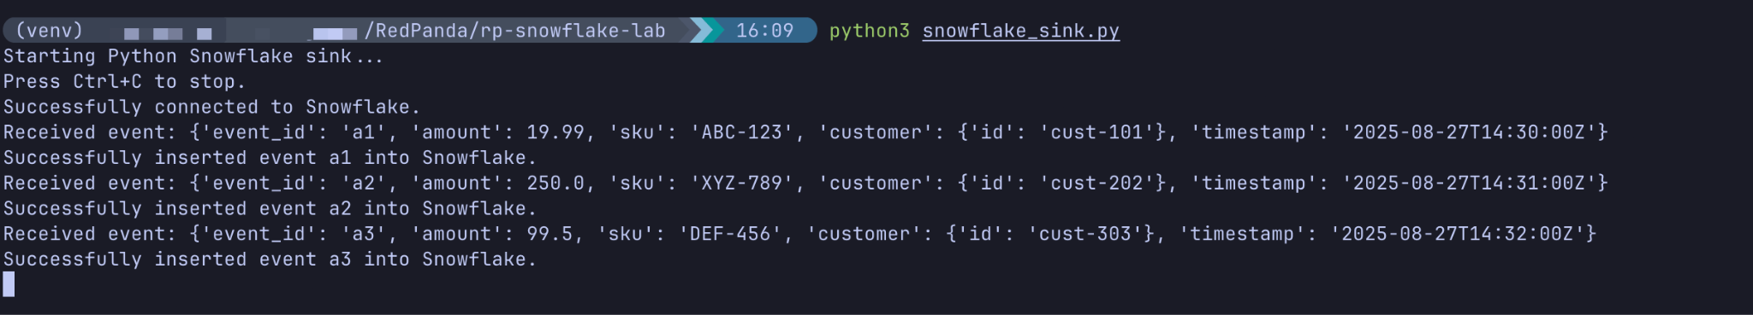

1. **Verify in Snowflake:** Go back to your Snowflake worksheet and run the SELECT query again.

|  |
| --- |
| **SELECT * FROM SALES_EVENTS ORDER BY EVENT_TIMESTAMP;** |

**Expected output:** You should now see all three records from your Redpanda topic ingested into the Snowflake table.

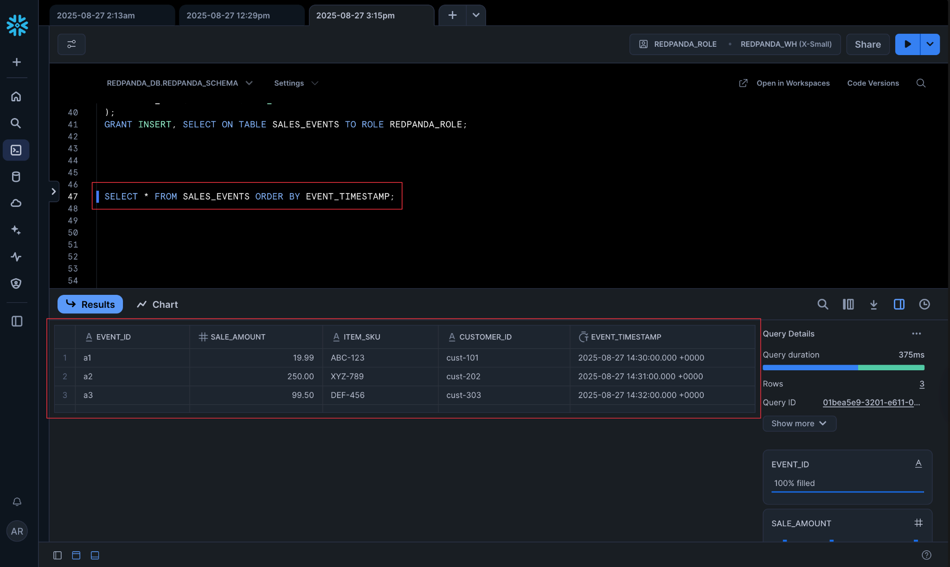

# Cleanup

1. Stop the connector with Ctrl+C.
2. Delete the Redpanda topic:

|  |
| --- |
| rpk topic delete sales-events-py --profile rpk-cloud |

1. In Snowflake, drop the objects.

|  |
| --- |
| DROP DATABASE IF EXISTS REDPANDA_DB;  DROP WAREHOUSE IF EXISTS REDPANDA_WH;  DROP USER IF EXISTS REDPANDA_USER;  DROP ROLE IF EXISTS REDPANDA_ROLE; |